Instructions for making graphs for Stage Class Data in Google Sheets:

1) Highlight the stage class data.

2) Click on Insert at the top and then Chart in the dropdown menu.

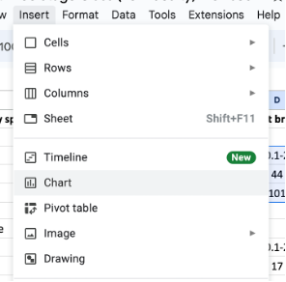

3) A bar graph may automatically pop up, but if a line graph pops up, just select
column chart in the drop down menu.

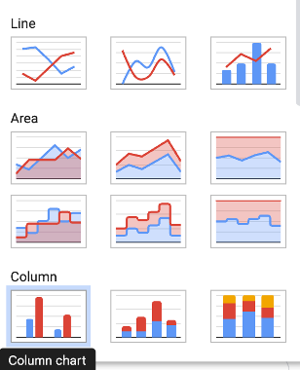

4) Double click on the title of the chart on the bar graph to change the title to the
name of the plant.

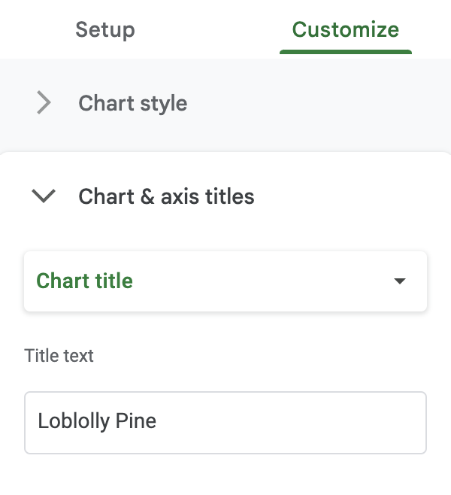

5) Click Customize, charts and axis title to add/change the title of the vertical or
horizontal axes.
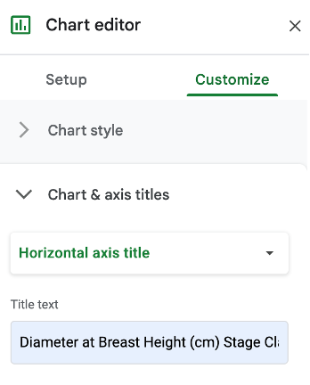

6) If you need to change the range of the vertical axis, double click on the vertical
axis and options will appear:

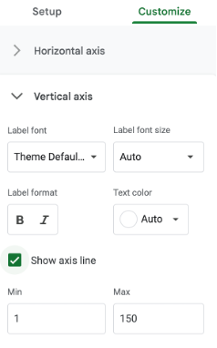
7) Your final graph should look similar to the one below:

